Session 1
1.
Install MySQL or PostgreSQL on your system and create a new database named 'music_streaming_app' using the command line or GUI tool of your choice.
ANS : CREATE DATABASE music_streaming_app;
USE music_streaming_app;
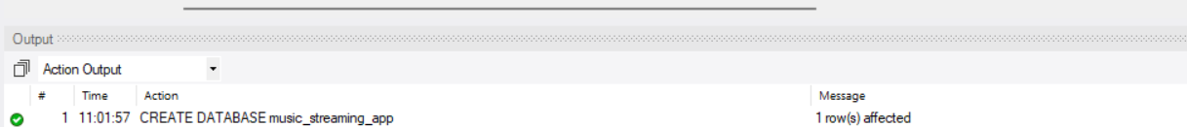

2.
Inside the 'music_streaming_app' database, create a table called 'playlists' with columns: playlist_id (integer, primary key), name (varchar), and created_by (varchar).
ANS : CREATE TABLE playlists ( playlist_id INT PRIMARY KEY, name VARCHAR(100), created_by VARCHAR(100) );

3.
Insert three sample rows into the 'playlists' table representing playlists like 'Bollywood Hits', 'Chill Vibes', and 'Workout Mix', each created by a different user.

ANS : INSERT INTO playlists (playlist_id, name, created_by)
VALUES
(1, 'Bollywood Hits', 'Amit'),
(2, 'Chill Vibes', 'Priya'),
(3, 'Workout Mix', 'Rahul');
4.
Write an SQL SELECT query to display all playlists created by the user 'Amit' from the 'playlists' table.<br><br><em><strong>Hint:</strong> Use the WHERE clause to filter by the 'created_by' column.</em>
ANS : SELECT *
FROM playlists
WHERE created_by = 'Amit';
5.
Open ChatGPT or Copilot and ask it to explain the difference between a table, a row, and a column in SQL using an example from a food delivery app like Zomato. Paste the explanation you receive into your assignment.

ANS : In SQL, data is stored in the form of tables. A table is a collection of related data organized into rows and columns. In a food delivery app like Zomato, a table can store information about restaurants, customers, or food orders.
A column represents a specific type of information (attribute) in the table. For example, a Restaurants table may have columns such as Restaurant_ID, Restaurant_Nam e, City, and Rating.
A row represents one complete record in the table. Each row contains all the details of one restaurant.

